Ideation Phase
Empathize & Discover

Date | 15 July 2026
Team ID | SWTID-2026-7507
Project Name | DarshanEase - Temple Darshan Ticket Booking App
Maximum Marks | 4 Marks

Empathy Map Canvas - Persona: Devotee Planning a Temple Visit
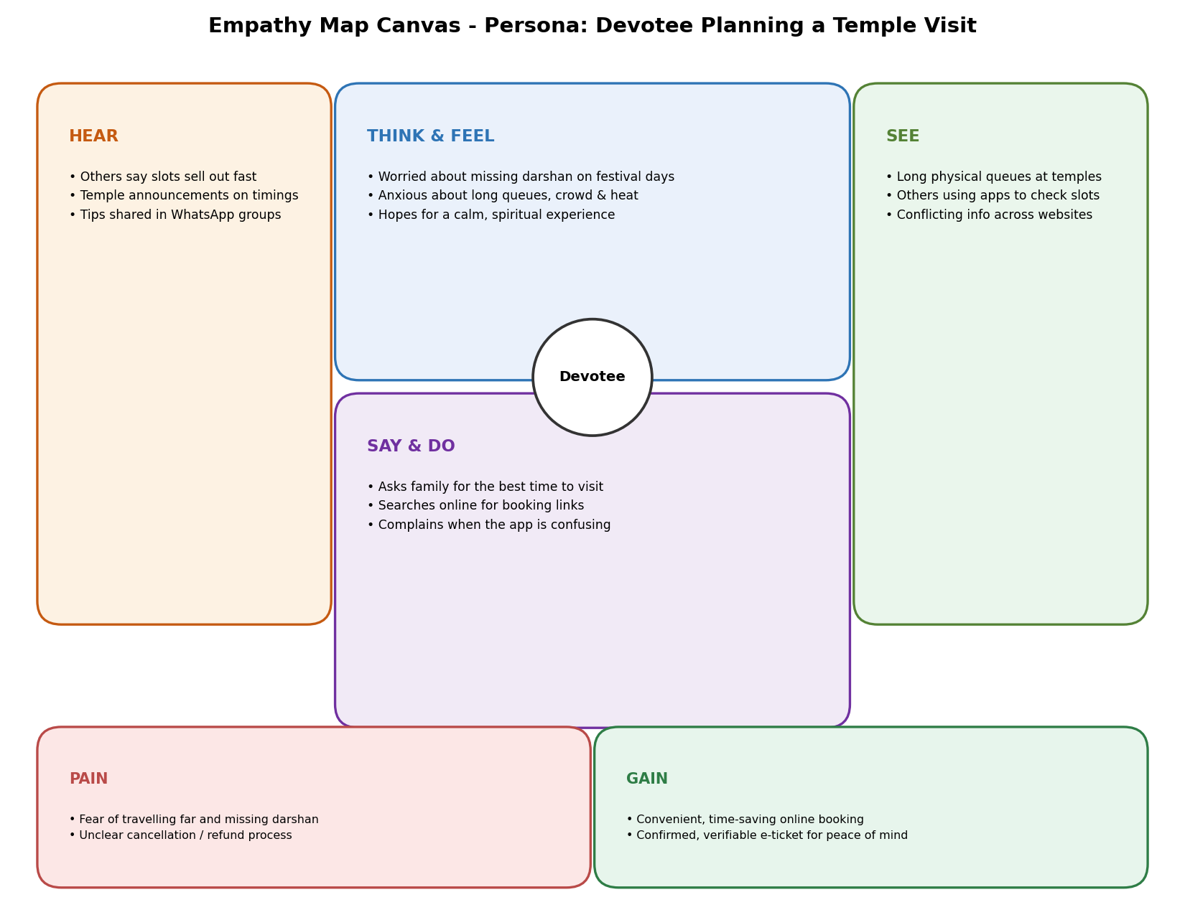
Canvas Detail:
THINK & FEEL  • Worried about missing the darshan slot on festival days  • Anxious about long queues, crowd, and heat while waiting  • Hopes for a calm, spiritual experience without last-minute stress | SEE  • Long physical queues and manual crowd management at temples  • Other devotees using mobile apps to check slot availability  • Conflicting information across temple websites and social media
SAY & DO  • Asks friends and family for the best time to visit  • Searches online for ticket booking links close to the visit date  • Complains when the booking app is slow or confusing | HEAR  • Hears from other devotees that slots sell out within minutes  • Temple announcements about pooja and seva timings  • Recommendations and warnings shared in community WhatsApp groups
PAIN  • Fear of travelling long distance and still not getting darshan  • Unclear cancellation and refund process  • Language barriers in booking apps for non-local devotees | GAIN  • Convenient, time-saving online booking from home  • Ability to choose preferred pooja type and time slot  • Peace of mind from a confirmed, verifiable e-ticket

